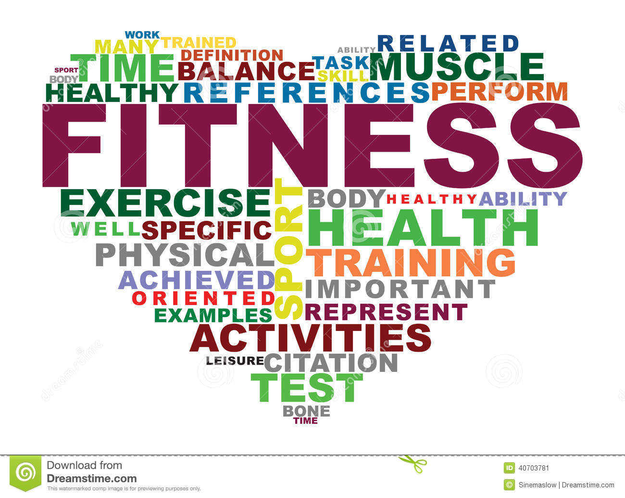

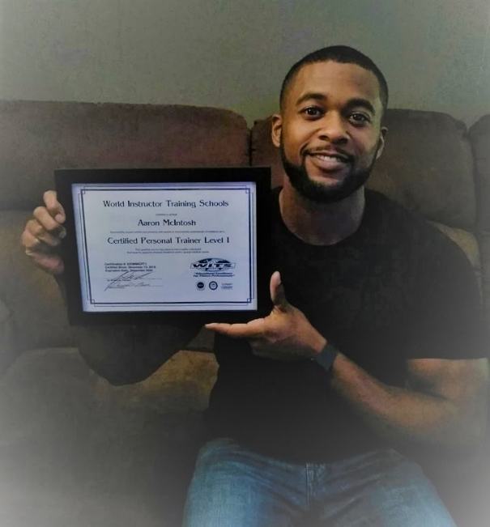

Live Rite Structured Recovery Corp presents:
Nutrition and Fitness Class
Starting on February 1st, Every Friday @ 8:00 PM
15465 E. 14 Mile Rd. Fraser, MI 48026
Live Rite Structured Recovery Corp, a non-profit organization under 501(c)(3) of the Internal Revue Code, Section 170.
(586) 217-5899  www.liveritestructuredcorp@gmail.com  liveritestructuredcorp@gmail.com

